1. **Test queries to see that you have loaded your database in the way you intended. Screen captures that shows that queries were executed successfully**

* Give the top-20 users by the number of comments they post

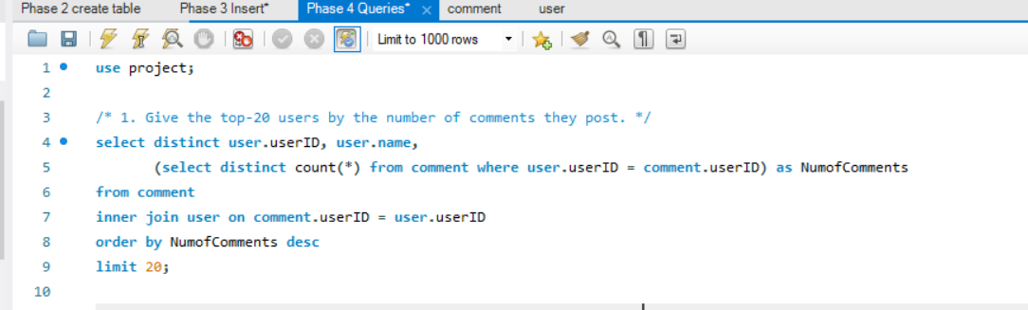

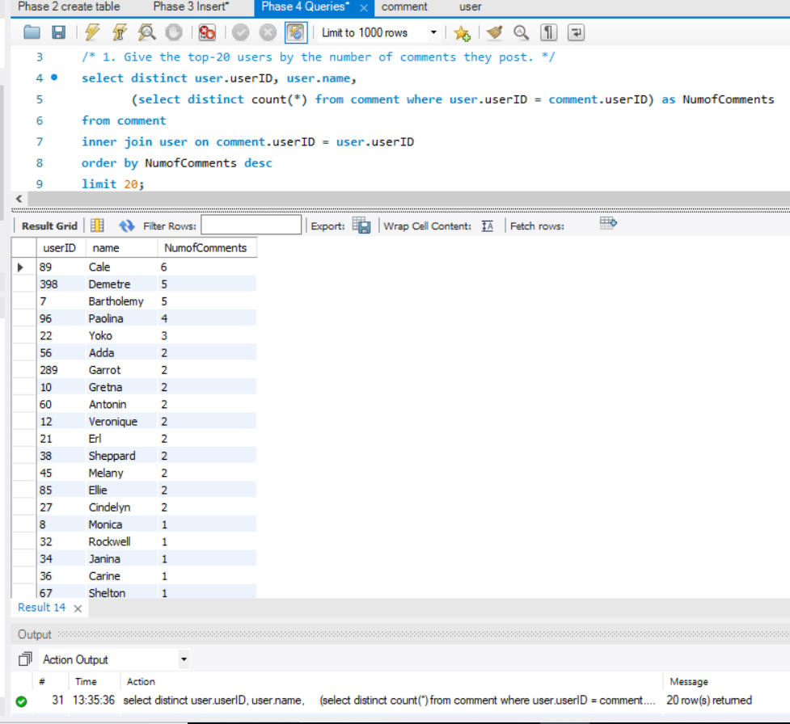

* Give the top-20 users by the number of replies they post

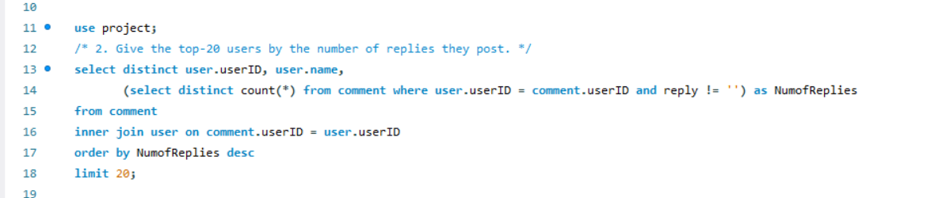

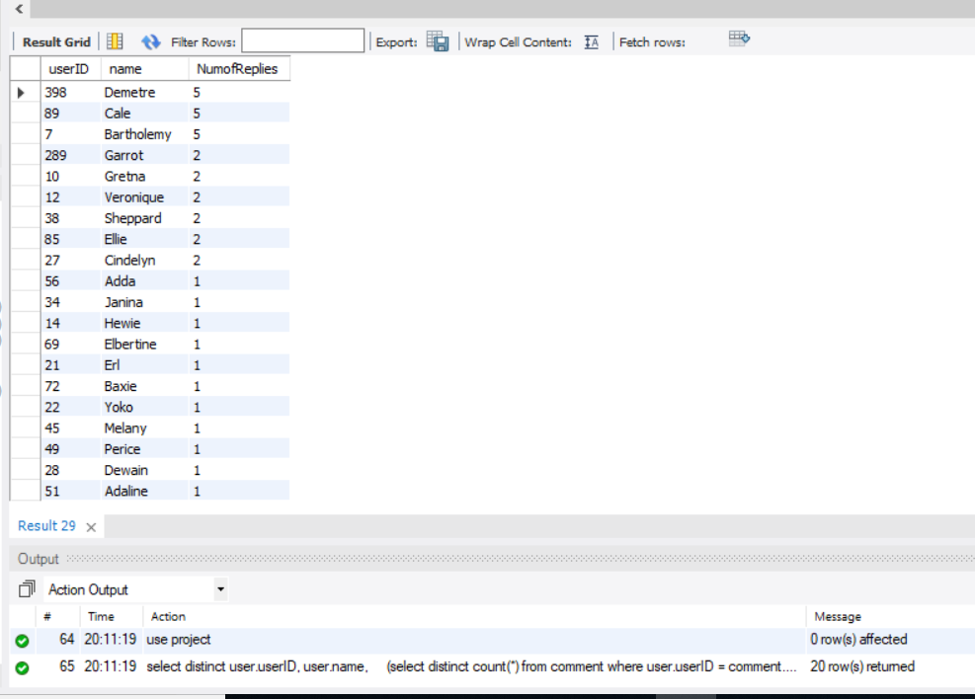

* Give the top-20 users by the number of like/dislike they post

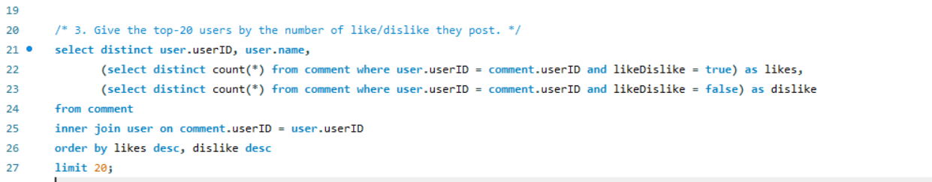

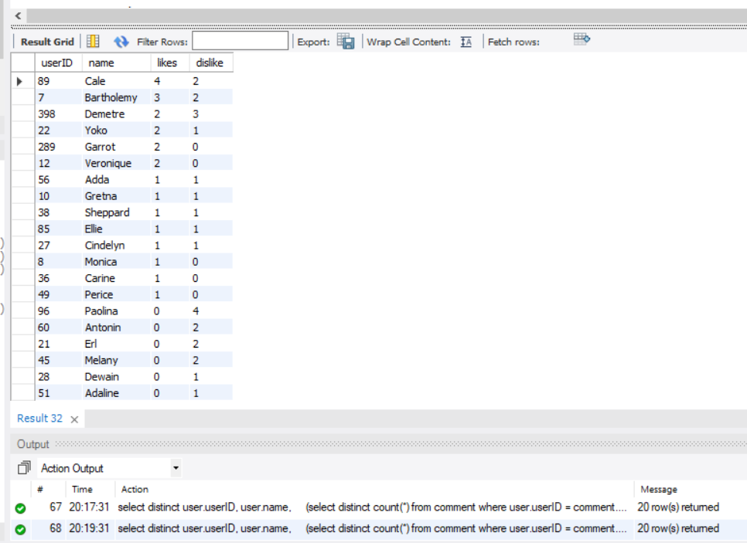

* Give the top-10 websites with the most requests for article comments
* Give the top-10 websites with the most sales this month/week/year

1. **Screen captures that shows that queries were executed successfully**
2. **Describe the challenges you met while implementing this phase of the project**